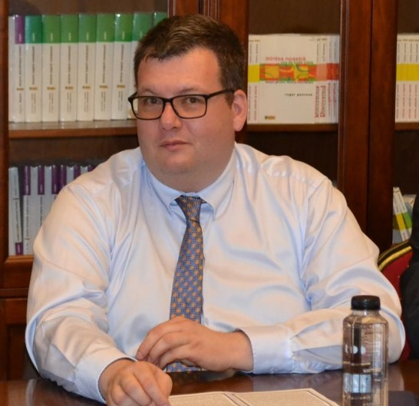
Dan-Cristian Dabija is a Full Professor at the Department of Marketing and PhD Supervisor in Marketing at the PhD School in Business and Economics of the Faculty of Economics and Business Administration, Babeș-Bolyai University, Romania. Dr. Dabija currently supervises six PhD Students. He completed his PhD Studies at the Bucharest University of Economic Studies, Romania, and has been awarded several doctoral and postdoctoral research scholarships at Romanian, German, Hungarian, Polish, British and Finish universities. Dr. Dabija has led research projects on sustainability and COVID-19 resilience in retail financed by the Romanian National Authority for Scientific Research and Innovation, but also an Erasmus+ Strategic Partnership on Business Negotiations (BNCOW). He has published more than 150 papers in various journals such as Amfiteatru Economic, British Food Journal, Computers in Human Behavior, Current Issues in Tourism, Frontiers in Environmental Sciences, Innovative Food Sciences & Emerging Technologies, International Entrepreneurship and Management Journal, International Marketing Review, Journal of Business-to-Business Marketing, Journal of Cleaner Production, Journal of Knowledge Management, Journal of Theoretical and Applied Electronic Commerce Research, has participated in numerous conferences (European Marketing Academy Conference, World Marketing Congress, Annual MBAA International Conference, Annual North American ACR Conference, RESER), and serves as an associate or guest editor for Amfiteatru Economic, Kybernetes, Journal of International Management, European Journal of International Management, Sustainability, as well as for Romanian and European research projects. His teaching and research fields are Retailing, International Marketing, Tourism Marketing, Sales Promotion/Business Negotiation, Artificial Intelligence, Sustainability, Consumer Behaviour and Strategic Marketing. Dr. Dabija has conducted different courses on project management, retailing, retail marketing, marketing, sales and promotions in summer schools, companies and human resources development courses. More recently Dr. Dabija coauthored in Romanian the book To conceive, to write and to publish a scientific article in business and economics, which was awarded in late 2017 the first book prize of the Romanian Association of Economic Faculties and in December 2019 the “Victor Slăvescu“ Prize of the Romanian Academy of Science. He was awarded in September 2018 the Publons “Excellent Reviewers“ Award and the “Top Reviewers in Economics and Business“, in September 2021 the “2020 MDPI Top Reviewer Award” and in April 2023 the “2022 Outstanding Reviewer Award” from the Journal of Risk and Financial Management. Since 2023 he is the best cited researcher in Marketing in Romania; according to the update of the science-wide author database of standardized citation indicators, he is ranked among the top 2% highly cited researchers (2023: #51745; 2024: #28497; 2025: #27660) by Elsevier and Stanford University International Ranking. In 2024 Dr. Dabija won the Emerald Literati Outstanding Paper Award for a coauthored paper in Journal of Knowledge Management, the 2024 Strategica International Conference Best Paper Award, while in 2025 he obtained the Emerald Literati Outstanding Reviewer Award and the 2023 International Scientific Award of the Hungarian Academy of Sciences. Since August 2024 Dr. Dabija serves as a member of the National Commission for the Attestation of University Titles, Diplomas and Certificates (CNATDCU) and since November 2024 Dr. Dabija is an associate member of the Academy of Romanian Scientists (AOȘR), Section IX, Economics, Sociology and Juridical Sciences. Since 2025 Dr. Dabija is a member of the National Council for Scientific Research from Romania (Committee Economic Sciences). In 2025 he received the “Ion Ionescu de la Brad” Award of the Romanian Academy of Sciences for a coauthored journal paper.
- Faculty web page: https://econ.ubbcluj.ro/cv.php?id=125
- Personal web page: https://sites.google.com/site/drecdancristiandabija/
- Academia.edu: https://independent.academia.edu/DanCristianDabija
- Ad Scientific: https://www.adscientificindex.com/scientist/dan-cristian-dabija/4347483
- Google Scholar: https://scholar.google.ro/citations?user=MqzkKtoAAAAJ&hl=ro
- LinkedIn: https://www.linkedin.com/in/ddabija/?originalSubdomain=ro
- LOOP: https://loop.frontiersin.org/people/678318/overview
- ORCID: orcid.org/0000-0002-8265-175X
- Web of Science: https://www.webofscience.com/wos/author/rid/I-8101-2012
- ResearchGate: https://www.researchgate.net/profile/Dan-Cristian_Dabija?addPub=1
- ScholarGPS: https://scholargps.com/scholars/71907334197312/dan-cristian-dabija
- SciProfiles: https://sciprofiles.com/profile/427007
- Scopus Author Page: https://www.scopus.com/authid/detail.uri?authorId=33567775800
- SSRN: https://papers.ssrn.com/sol3/cf_dev/AbsByAuth.cfm?per_id=1908133

